**Project on**

Palm Oil Production Database

**Developed By:**

Abdurrahman Yaqub

**Reg NO:**

R213030200140

**NIIT**

Batch code :

End Date : 18th AUGUST,2021

Name of coordinator : Mr. Imoh

Name of developer : Abdurrahman Yaqub

Date of submission : 18th AUGUST,2021

Acknowledgment

I want express my special thanks to our instructor Mr. Imoh, as well as the management for giving me this opportunity to add this wonderful project on the topic Palm oil production database which has broadened my horizon of knowledge from researches and as such I’m able to handle similar tasks in the future. And to my friends who helped us a lot in finalizing this project within the limited time frame.

Suppliers table screenshot

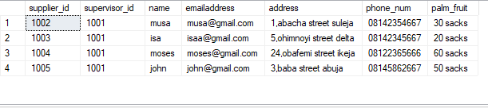

Palm oil production staff

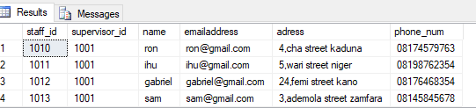

Daterbases are integral part of an organization, they are designed to improve and manage data, storage, manipulation such as adding , editing and deleting data. This is done using a software known as SQL SERVER, it comes in various types but we are going to focus on using the MICROSOFT SQL SERVER.

HOW TO CREATE A DATABASE?

To create a database is simple if carefully and correctly done. Here are steps to follow.

* Make a list of entities or objects that make up a company or business you’re creating the database for
* Make a list of attributes that make up each entity
* Find the relationship between each entity you have
* The next thing to do is to create an er diagram
* Map the er diagram to the table
* Identify various schemas involved
* Normalize the table to have 3NF
* Draw a diagram to show the relationships between the various tables
* Go to your SQL SERVER and CREATE A DATABASE
* Create tables as per the relationship diagram, ensuring minimum disk space utilization

Here are few of my codes:

CREATE DATABASE palm_oil_production

on primary

(name = "palm_oil_production",

filename = 'C:\Program Files\Microsoft SQL Server\MSSQL12.MSSQLSERVER\MSSQL\DATA\palm_oil_production.mdf',

size=10mb,

maxsize=100mb,

filegrowth=5mb)

log on

(name = "palm_oil_production",

filename = 'C:\Program Files\Microsoft SQL Server\MSSQL12.MSSQLSERVER\MSSQL\DATA\palm_oil_production_logs.idf',

size=10mb,

maxsize=100mb,

filegrowth=5mb)

use palm_oil_production

create table palmoilproduction_suppliers

(

name char(25) not null primary key,

emailaddress char(50) not null,

address varchar(150) not null,

phone_num char(11) not null

)

insert into palmoilproduction_suppliers

values('musa','musa@gmail.com','1,abacha street suleja','08142354667'),

('isa','isaa@gmail.com','5,ohimnoyi street delta','08142345667'),

('moses','moses@gmail.com','24,obafemi street ikeja','08122365666'),

('john','john@gmail.com','3,baba street abuja','08145862667')

select * from palmoilproduction_suppliers

create table palmoilproduction_staff

(

staff_id int primary key,

name char(20) not null,

emailaddress char(50),

adress varchar(150) not null,

phone_num char(11) not null

)

insert into palmoilproduction_staff

values(1010,'ron','ron@gmail.com','4,cha street kaduna','08174579763'),

(1011,'ihu','ihu@gmail.com','5,wari street niger','08198762354'),

(1012,'gabriel','gabriel@gmail.com','24,femi street kano','08176468354'),

(1013,'sam','sam@gmail.com','3,ademola street zamfara','08145845678'),

(1014'abba','abba@gmail.com','1,cha crescent suleja','08142354667'),

(1015'natahn','nath@gmail.com','7,ohimnoyi street delta','08142345667'),

(1016'grant','gra@gmail.com','2,femi street ikeja','08122365666'),